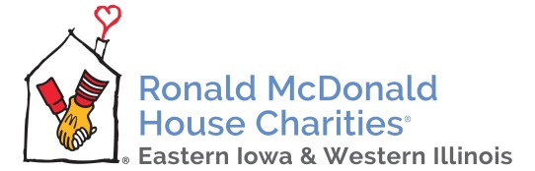 | Ronald McDonald House Charities  of Eastern Iowa and Western Illinois  730 Hawkins Drive  Iowa City, Iowa 52246

News Release

Wednesday, June 17, 2020

FOR IMMEDIATE RELEASE

Contact: Heather Croskrey, Development Director, (319) 550-4138

The Ronald McDonald House Charities of Eastern Iowa and Western Illinois (RMHC-EIWI) Board of Directors announces the departure of Executive Director, Barbara Werning, after almost five years of service. Werning has accepted a position with the Heritage Agency on Aging in Cedar Rapids, IA. Her resignation is effective June 30, 2020.

Werning’s tenure with RMHC-EIWI brought many positive changes, from recruiting outstanding staff members, operational improvements, and over 4,000 families served. The charity also opened a new Ronald McDonald Family Room at the University of Iowa Stead Family Children’s Hospital and began extensive renovations to the 35-year-old building that serves as the Ronald McDonald House of Iowa City. Several important community partnerships, including Ethan Allan in Coralville and the Gerdin Family, were formed under Werning’s administration.

“Barbara leaves RMHC-EIWI in a very strong position for future growth and we sincerely thank her for her contributions and leadership these past five years,” states Jamie Henderson, President, Board of Directors. “During this transition, we maintain our commitment and dedication to keep families with sick children together when they need it most.”

Shannon Greene, Operations Director, has been appointed Interim Executive Director to ensure continuity and support the transition to a new Executive Director. The Board has begun a search for the best candidate to lead RMHC-EIWI into the future.
###

About Ronald McDonald House Charities of Eastern Iowa and Western Illinois: Ronald McDonald House Charities of Eastern Iowa & Western Illinois strives to keep families close to each other and the care they need, when they need it most. RMHC-EIWI provides care and comfort to children receiving medical treatment and their families by supporting the 31-room Ronald McDonald House of Iowa City. Additional programs include a Ronald McDonald Family Room at St. Luke’s Hospital in Cedar Rapids and a Ronald McDonald Family Room at University of Iowa Stead Family Children’s Hospital. Learn more at rmhc-eiwi.org.

